used to change the icons of any software

replace text

chage icon

change bitmap

change cursor

[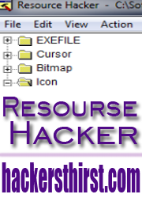](https://lh6.googleusercontent.com/-bb9dwOswQlw/TYIAktatdpI/AAAAAAAAAjE/hTFJc6J4Rsg/s1600/title-resourse-hacker-hackersthirst.png)

Here, i will define interface and working of the resource hacker. A great tool for hacking .exe files and many others. We can use it to configure and re-design many windows interface related applications. Such as last time when this site *hackersthirst* was new i posted a trick on how to change start menu button text.  
  
>> [Change Text on Windows Xp Start Menu Button](http://www.hackersthirst.com/2011/02/change-text-on-xp-start-button.html)  
  
In this trick i used this software. So, lets see what more we can do with this randomly as purpose of *hackersthirst* is to make you more creative rather then being at same line.

**What is Resource Hacker?**

Resource Hacker is a utility to view, modify, add, rename and delete resources in Windows executables and resource files. Furthermore, Resource Hacker also includes an integrated resource compiler and decompiler. It can modify *.dll , *.exe , *.cpl , *.ocx etc. It was developed by Angus Johnson and is present in an ope source license.   
  
***Download:***  
  
Download this software from [*here*](http://www.ziddu.com/download/14225780/ResHackHackersthirst.com.rar.html)to learn ow to take benefits from it.  
  
After downloading the setup file. Just install it and a shortcut will appear in you start up manu. From there Run the software.

**Basic Interface After Loading Any *.exe File:**

Locate and *.exe file which you want to open. and then click ***Open***from the ***File***menu of software and browser for *.exe or any supported file and then open it. I have loaded a file, See pic below, this file has used maximum Resource Hacker Options.

[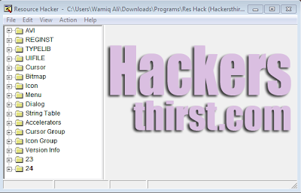](https://lh4.googleusercontent.com/-XhMmeg6QnAA/TYIGb-W2vEI/AAAAAAAAAjI/tdMADC8yEuA/s1600/interface-resourse-hacker.PNG)

Now the *.exe has following things loaded with it which we can hack:  
**AVI>>**                      *Contains Avi Files*  
**Cursor>>**                 *Contains Cursor interface Files*  
**Bitmap>>**                *Contains BMP files to make *.exe (Or other supported format) attracting*  
**Icon>>**                     *Contains Icons shown for *.exe (Or other supported format) in Windows*  
**Dialog>>**                 *Contains Dialog Boxes*  
**Version Info>>**        *Contains Version Info for *.exe (Or other supported format)*  
**Menu>>**                  *Contains Files for Menus*  
**Accelerators>>**       *Contains Shortcut Keys Information*  
  
  
Viewing and Hacking (Changing) the resources:  
Now, Its quite Simpler for you to scroll the resources as required and to change them.

**First lets work with Icons/Cursors/Bitmap:**

***Icons:***  
I have opened setup of the resource hacker in resource hacker itself. Lets, See what i can get:

[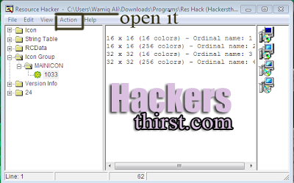](https://lh4.googleusercontent.com/-Ljc-myWW8eY/TYIPsLPdTWI/AAAAAAAAAjM/Bc6ESRqrIrE/s1600/icon.PNG)

Yes, i have got the icon of the *.exe . Now, i can make an advanced more better looking icon and can replace with these ones. Their dimensions aslo given. Click on ***action*** and there is option of ***replacing icon***.

[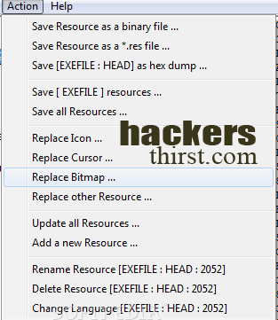](https://lh5.googleusercontent.com/-VnaXXy2OI1Y/TYIQlSgBLYI/AAAAAAAAAjQ/YKcLJ-mKZ1c/s1600/action-menu-rosourse-hacker.png)

As you can see that you can do a lot with these options, Click on ***replace cursor*** and give *.exe the cursor of your choice.  
  
***Bitmap:***  
You might have seen that some applications have pictures inside them these are in bitmap format. Yes, you can also hack them to change. Lets say you have compiled an application now you want to change interface now resource hacker will help you a lot. Just ***open application***, go to ***bitmap*** and select wanted ***resource***. Design your new resource of bitmap file in [*adobe photoshop*](http://www.hackersthirst.com/2011/01/adobe-photoshop-cs5-extended-crack.html). Save it, and replace your resource.  
  
  
***Cursor:***  
Similar is the case with cursors, you can make your own stylized cursors ot get some from internet to make your application more suitable or user friendly just navigate to ***cursors*** and then ***action*** and afterwads***replace resource***.   
  
  
***Hacking (Changing) Other Resources Like AVI:***  
1) Click on Action.   
2) Replace Other Resource and provide the AVI file.

[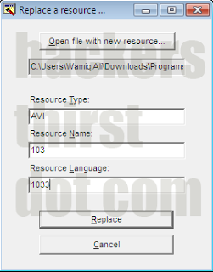](https://lh3.googleusercontent.com/-TP7iegv--Ds/TYITYUwf7PI/AAAAAAAAAjU/iRGe7dHUgmg/s1600/AVI+hacking.PNG)

***Note: Resource Name should be same as present earlier. Also use 1033 for english language.***

3) In end Click on ***Replace*** Icon. 

**Modifying Dialog Boxes And Other Advanced Things:**

We can also modify text and display of the dialog boxes in the applications. Like i edited following One:

[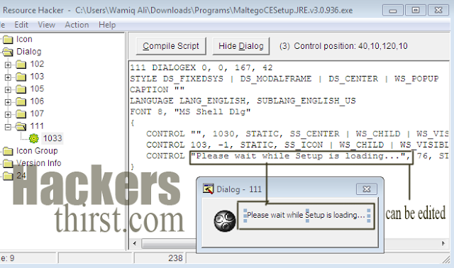](https://lh3.googleusercontent.com/-8CaBf1yK6YI/TYIZEjHi1qI/AAAAAAAAAjY/SxdD3zgm7PU/s1600/replacing+dialogs+hackersthirst+hack.PNG)

After changing the values ***compile*** the script and that it. Now software or application will show required text.

**Adding New Menus:**

Go to desired menu, e.g. Menu -> 115 -> 1033. Now add a new line anywhere inside **POPUP ""** using following format:

*MENUITEM "Custom_String", 12345, MFT_STRING, MFS_GRAYED | MFS_DEFAULT*

Explanation:  
  
>> "*Custom_String*" is the actual text which you want to show in menu.  
*>> 12345* is the identifier. It must be different from existing menuitems.  
**>> MFS_GRAYED** disables the menuitem. You can change it to **MFS_ENABLED** if you want to show    your menuitem enabled.  
**>> MFS_DEFAULT** shows your menuitem in **BOLD**. You can omit it.  
>> You can also add a new attribute in the code **MFS_HILITE** which automatically selects your menuitem.  
  
In fact you can only add following new line in code:

*MENUITEM "Custom_String", 12345*

And Resource Hacker will automatically insert other remaining values as mentioned above.

**Adding Options In dialog Boxes:**

You can add further options in dialog box also, Just ***right click*** at it (Dialog Box) and then click ***Insert Control***. This will appear:

[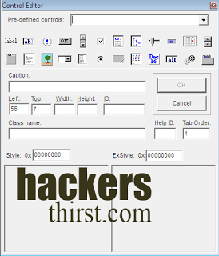](https://lh5.googleusercontent.com/-JdksvWEJuYQ/TYIfAkxglYI/AAAAAAAAAjc/LhSkU60LC5M/s1600/controls.PNG)

Yes, You can add many options, and also also specify their positions. Just click Ok after done and compile it.

***Note: Don't forget to fill the Caption entry. You need to enter the Resource Name in Caption textbox, e.g. if you have added a Bitmap and set its Resource Name as 401, then give the same 401 in Caption textbox. Also, for AVI Control ( SysAnimate32 ), you'll need to append # in Caption value, e.g if the AVI name is 144, then put #144 in Caption textbox.***

- See more at: http://www.hackersthirst.com/2011/03/resource-hacker-smart-tool-all-about.html#sthash.yHtF3Rte.dpuf